**Online wedding Planner**

An Online Wedding Planner website is a comprehensive digital solution designed to simplify and enhance the wedding planning process for couples. It combines various tools, resources, and services into one user-friendly platform, allowing couples to manage every aspect of their wedding efficiently and effectively.

**Purpose**

The primary purpose of the Online Wedding Planner website is to streamline wedding planning, reduce stress, and provide couples with the tools they need to create their dream wedding. By offering a centralized hub for all wedding-related tasks, the platform fosters collaboration between couples, families, and vendors while ensuring that no detail is overlooked.

1. User Use Case Diagram

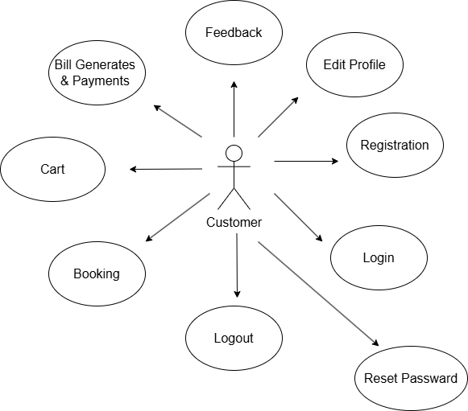

1. Event Organizer Use Case Diagram

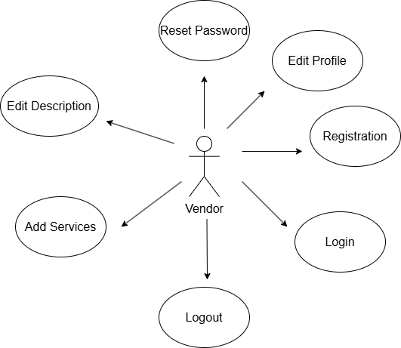

1. Admin Use Case Diagram

